[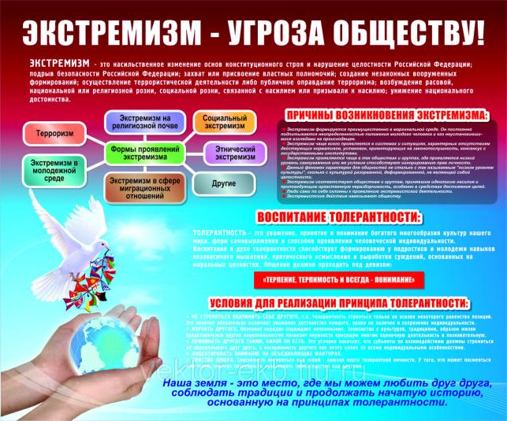](http://go.mail.ru/redir?src=2169f4&via_page=1&type=sr&redir=eJzLKCkpsNLXL6kszUlPzDM10ysq1c_MS8svyk1MzqxM1C8oyi_JLMtPSa0sLinLTNUtSS0qyi_KrMot1c3UBUqmZeYkZpdkZifqpmYXlxSl5gKlEhkYDE2BwMzEyNyMYXVxyJd_FZOPJRo95BJnf6QJAMjSK2Q)